Chapter 2: Trust as a Computational Problem
Before we can compute trust, we must define what it means. This chapter explores why trust in networks is fundamentally a mathematical problem of uncertainty and risk, establishing the language used throughout this book.

Why Trust Requires Mathematical Formalization
In modern networks, thousands of devices make millions of access requests per second. Trust cannot rely on human intuition; it must be a computable, dynamic number. This chapter argues why we need explicit mathematics for three concepts:
Trust is derived from observable evidence (Eq 2.1).
Trust is perishable and decays over time (Eq 2.3).
Access requires tiered risk boundaries, not binary switches (Eq 2.2).

Introduction
This chapter reviews the evolution of modern enterprise networks and the roles of different types of identities in user authentication and trust estimation to guide access decisions per requests. It also reviews the architecture of software defined networks and perimeters and their effectiveness to network growth and scaling. The culmination of these is also a research gap to justify this work and a conceptual framework that discusses the resultant testbed that will be the outcome of this work.

Theoretical Framework

Underlying Security Principles
Principle of Fail- safe Defaults: this states that, unless a subject is given explicit access to an object, it should be denied access to that object. This principle requires that the default access to an object is none. Whenever access, privileges, or some security-related attribute is not explicitly granted, it should be denied. Moreover, if the subject is unable to complete its action or task, it should undo those changes it made in the security state of the system before it terminates. This way, even if the program fails, the system is still safe (Stallings & Brown, 2018).
Least privilege principle: This is a well-known security practice to reduce the risk of credential theft or data misuse and leakage.it ensures that users and applications only have the minimum privileges needed to perform their intended tasks For example, for data stored in a networked or cloud server meta-data a user should not have full access to all services. the system provisioned would have huge security risks if this was the case. Although least privilege is regarded as an important practice, discovering the least-privileged is an error-prone and burdensome task because the process tends to be trial and error. The permissions should be limited to reduce security risks, but insufficient permissions cannot satisfy a system’s requirements (Shimizu & Kanuka, 2020) and (Wu & Feng, 2021). This principle thus defines a rule of thumb for the default permissions and trust levels for users accessing resources within an enterprise.
Complete Mediation principle: The principle of complete mediation requires that all accesses to objects be checked to ensure that they are allowed. Whenever a subject attempts to read an object, the system should mediate the action. First, it determines if the subject is allowed to read the object. If so, it provides the resources for the read to occur. If the subject tries to read the object again, the system should check that the subject is still allowed to read the object. This ensures that checks are always performed before access requests are granted. This guarantees that security checks are performed before and not after transactions have been performed. It thus becomes a prevention principle and not an audit mechanism. For performance improvements, most systems would not make the second check. They would cache the results of the first check and base the second access on the cached results.
Separation of privileges principle is defined in as a practice in which multiple privilege attributes are required to achieve access to a restricted resource. It therefore ensures that a system should not grant permission based on a single condition. A good example of this is multifactor user authentication, which requires the use of multiple techniques, such as a password and a smart card, to authorize a user. The term is also now applied to any technique in which a program or data is divided into parts that are limited to the specific privileges they require to perform a specific task. This is used to mitigate the potential damage of a computer security attack. One example of this latter interpretation of the principle is removing high privilege operations to another process and running that process with the higher privileges required to perform (Stallings & Brown, 2018).
The architectural realization of Zero Trust is theoretically anchored in the foundational cybersecurity principles of "fail-safe defaults" and "deny-first." Historically, network engineering favored an "allow-by-default" topology to prioritize seamless connectivity and availability. Security practitioners were forced to construct extensive blacklists, firewalls, and intrusion detection systems in an attempt to identify and block malicious anomalies on an already open network.
The fail-safe algorithmic default fundamentally inverts this operational logic. Under this principle, a system mathematically defaults to a secure, restrictive, offline state; it denies all environmental visibility and access unless explicit, cryptographically sound authorization is presented and actively maintained (Turner & O'Connor, 2024). Recent theoretical literature highlights that this "deny-first" approach is the granular, operative mechanism that makes Zero Trust functional across highly complex, cloud-native frameworks and autonomous agentic communication systems (Davidson, 2025; Turner & O'Connor, 2024).
When an entity attempts to access a resource under ZTA, it is treated as inherently hostile (embodying the "assume breach" mentality). By defaulting to denial, the architecture proactively limits initial exposure and neutralizes lateral attack surfaces. Critically, if an authentication service crashes, a software agent encounters an operational exception, or a device's telemetry feed goes silent, a fail-safe system does not fail "open" to preserve business continuity; it fails securely by instantly revoking the network entitlement (Davidson, 2025). Ultimately, fail-safe defaults represent the tactical, mechanical implementation of trust denial, while Zero Trust serves as the overarching strategic framework governing its enterprise-wide application.
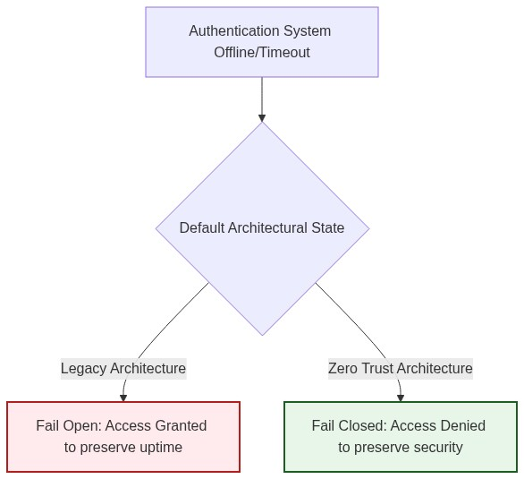
Figure 2.1: The divergence between Fail Open and Fail-Safe architectures during system exceptions.

Heterogeneous Enterprise Network Landscape
In recent years there has been an increase in the evolution and proliferation of technology in our daily lives. The number of smart-phones, mobile-connected wireless devices, social networks, and sensors being used has grown substantially due to the emergence of the concept of Internet of Things (IoT) (Moubayed et al., 2019). These developments have been in place to help facilitate more pervasive and ubiquitous computing among different users of computing devices. This has thus resulted in much change in enterprise computing in the last two decades with the appearance of new approaches such as cloud and edge computing, the (industrial) Internet of Things (IIoT) and computing on demand. These environments have been characterized by distributed interactions on a scale not seen heretofore with attendant high levels of complexity and dynamicity – including mobility -heterogeneity and uncertainty (Vanickis et al., 2018).
The complexity has been further compounded by the multiplicity of telecommunication transmission and media access, which can be reflected by the coexistence of optical fiber communications, power line communication, wireless local access network, wireless sensor network, public network GPRS/CDMA, 3G, 230MHz cable/wireless and public network/special network, with different and supplemented coverage areas, multiple and heterogeneous communication systems, wide and concurrent access, and the changeable and rough communication environment (Guo & Ren, 2015). Many different types of network communication have also emerged over the years as illustrated in Figure 1. On one end of the spectrum, there are asynchronous store and forward networks, such as email. On the other end, there are synchronous networks, such as real-time voice communication or devices worn on the same body. Either way, devices and their heterogeneous networks are getting more pervasive. They all have in common that their communication should be secured to protect confidential data (Schürmann, 2017) and (Das & Debnath, 2020).

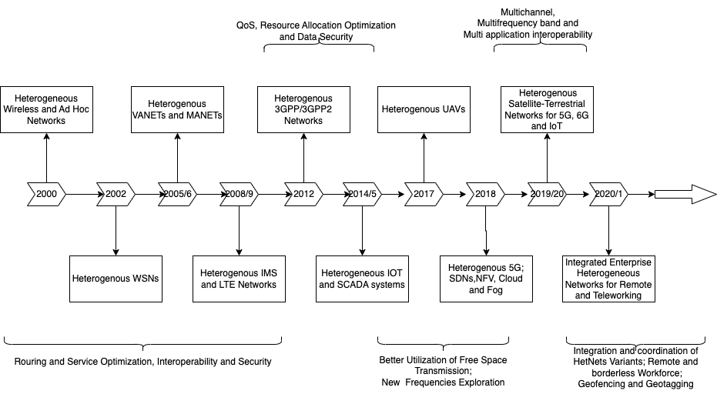
Figure 2.2: Evolution TimeLine for Heterogenous Networks

Additionally, emerging networks such as 4G and 5G systems as well as other phenomenon such as BYOD and teleworking have resulted in complexities to enable elements such as mobility, virtualized infrastructures, dynamic and heterogeneous user contexts and transaction-based interactions. This is illustrated in Figure 2 on integrated heterogenous enterprise network environments. The uncertainty introduced by such dynamicity introduces greater uncertainty into the access control process and motivates the need for risk-based access control decision making (Vanickis et al., 2018).

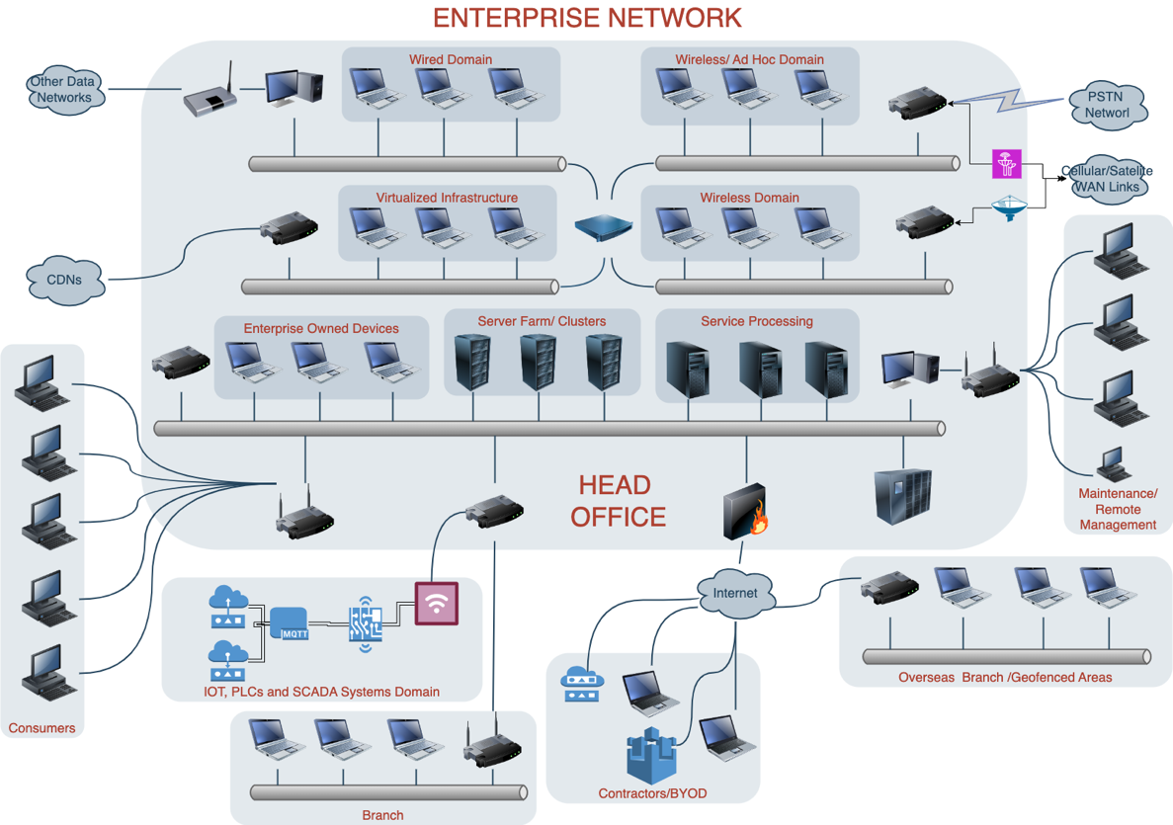
Figure 2.3: Structure of Integrated Heterogenous Networks

It is therefore apparent that most enterprise networks today are inherently heterogeneous, comprising devices, protocols, services and architectures with varying characteristics. This heterogeneity stems from diverse devices including IoT sensors, mobile devices, legacy systems, cloud servers, and edge nodes with differing computational and security capabilities. With the need for communication across these devices, then multiple communication protocols to support lossy and lossless communications and busty connections are also required. Variations such as TCP/IP, Zigbee, MQTT andBluetooth) lead to fragmented security implementations which lead to extended surfaces of attacks. There is also significant adoption of elastic and off-premise cloud infrastructure to reduce cost of ownership and flexibility of access to resources which further compounds the heterogeneity and creates complexity in interoperability and compatibility with legacy systems that are often unpatched or lacking modern security features, coexist with newer devices and platforms. The dynamicity and mobility of most of the devoces also introduce frequently changing contexts, metadata and anchor points between transitioning between edge networks, local infrastructure, and the cloud.
The diversity of these heterogenous environments creates significant challenges for managing trust, enforcing consistent security policies, and ensuring seamless interoperability.
To handle the increasing number of devices, technologies and paradigms, risk-based access control to resources needs to be dynamic and context aware in order to a consider the variants of resources available in enterprise networks. Moubayed et al., (2019) hinted at an amalgamation of technologies and paradigms such as zero trust, cloud computing, software-defined networking (SDN), and network function virtualization (NFV) for better security in such heterogenous environments.

Malware and Misuse Propagation on Heterogenous networks
With the permeation of heterogeneous enterprise networks, with their diverse components such as wireless systems, IoT devices, legacy systems, virtualized nodes, cloud platforms, and edge nodes, there is a complex and dynamic attack surface that can be exploited for resource misuse or system intrusions (Vanickis et al., 2018). Intrusions and misuse incidents often arise due to inadvertent challenges and deliberate exploitations revolving around user, application and physical attack surfaces. Layered attacks including insider and outsider attacks are good examples of threats on the user surface. Authorized internal users with knowledge on system functionalities may misuses their access privileges and originate attacks resulting in data leaks and /or unauthorized modification of data resources or metadata such as configurations. External attackers on the other hand mostly target poorly secured IOT devices, legacy systems or inconsistencies in patches on nodes and hosts to gain unauthorized access, perform unauthorized modifications or alter system configuring metadata to result in unwanted unavailability. In some instances, threats such as disruption and usurpation mya result from configuration missteps due to permissions overuse or unfettered access for unprivileged users. Misconfigurations in access control policies across heterogeneous devices lead to unintentional permission escalation leading to other potential risks such as disclosure and deception. While most misconfigurations result from oversight, the unmonitored deployment of devices and applications within the network especially for better management, convenience of deployment or as hooks and extensions to existing topologies and pipelines introduces unknown vulnerabilities as discussed by Li et al. (2019) and Ferraris et al. (2023). These applications and devices, referred to as shadow IT further introduce points of misuse and intrusions especially in heterogenous domains.
Furthermore, with the heterogeneity, there is a more dynamic threat landscape especially because of the presence of a powerful and distributed nodes that come from the IoT domain and embedded systems. Other attack vectors such as malware, phishing, and DOS vectors, disproportionately exploit their inherently weak security mechanisms, unchecked trust relationships between nodes in these diverse systems. This asymmetry eventually overwhelm the defense mechanisms of more secure and trusted network domains and segments. (Wang et al., 2018) and (Rehman et al., 2022).
With the permeation and adoption of heterogeneity in enterprise networks, both the number and severity of cybersecurity incidents have grown dramatically. Some examples include, in an attack on the global financial messaging network SWIFT in 2016 that resulted in over $80 million in losses to financial institutions in Asia including in Bangladesh, the Philippines, Sri Lanka, and Vietnam. This attack highlighted the ongoing need for protection against insider threats from within a presumably trusted network and a lack of rigorous authentication and identity management for network users. Many other incidents have demonstrated a need for improved defense against automated cyberattacks, including botnets and crypto ransomware. Further, in 2016, several notable distributed denial-of-service (DDoS) attacks occurred, harnessing botnets comprised of security cameras, baby monitors, home appliances, and other devices on the Internet of Things (IoT). Mirai botnet disrupted DNS servers at the service provider Dyn, affecting millions of users on Twitter, Amazon, Spotify, Netflix, Tumblr, and Reddit (Eidle et al., 2018).
The dramatic escalation in both the number and sophistication of security-attacks on business in recent years, will continue to grow in coming years– a factor that merely adds to the computing environment complexity (Vanickis et al., 2018). The permeation of more heterogenous networks within enterprises further introduces new frontiers for malware and misuse propagation against the data handled and owned by these enterprises. Additionally, the increase in both frequency and severity, has further exposed traditional defense methods as inadequate and reactive to these vulnerabilities(Sheikh et al., 2021). Some of these challenges as illustrated in Figure 2.3
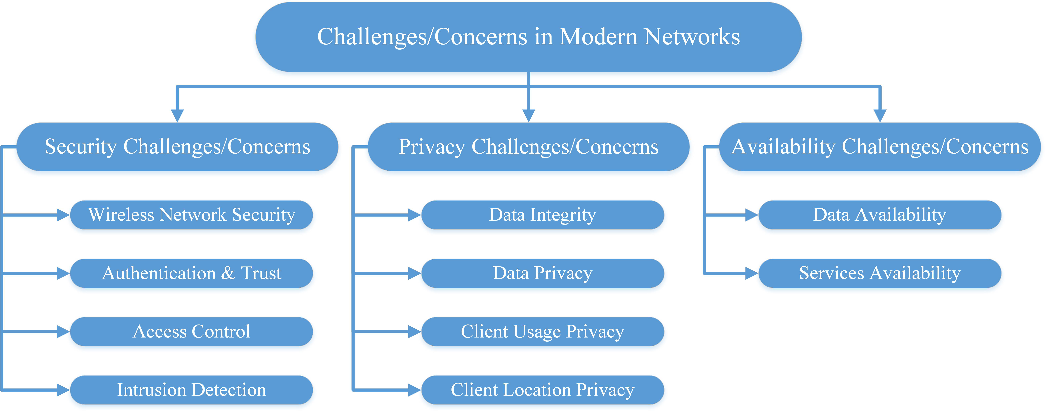
Figure 2.4 Modern Network Challenges Addressed by Zero Trust (from: (Moubayed et al., 2019))

Even more concerning, the cyber-defense capabilities of many organizations are already stretched to their limits. According to the 2017 Security Capabilities Benchmark Study, most organizations can only investigate about half of the alerts they receive on any given day. This is at least partly due to the massive number of potential security alerts that must be processed; 44% of security operations managers receive over 5,000 security alerts per day. In this environment, less than half (about 46%) of legitimate security alerts are addressed, while the remainder are left uninvestigated. There is a corresponding need to improve both efficiency and response time to immediate threats; automated systems are good candidates for this approach (Eidle et al., 2018).
Since almost every network user possesses several types of communication devices that are being used in different locations, under different environmental conditions, situations, and time frames. These devices can share common forms of use, they all have distinctive characteristics, strengths, and weaknesses. Therefore, heterogeneous network allows for different routes and methods of malware propagation. One can generalize different paths of malware and misuse propagation heterogeneous networks as following:
- compromised device (malware) subjected to device-to-device synchronization by user and leads to the compromise of other devices of the user.
- common application software on different devices of the same user; first device is compromised then device to device synchronization by the user leads to compromise of other devices of the user.
- network users share software; software compromised based on user–user propagation or device-to-device synchronization leading to other devices being compromised.
- Device of one user compromised by malware via email/download/link; the user synchronizes other devices leading to the other devices of the user being compromised.
- Device of one user compromised by malware via email/download/link the user/device sends email to /shares the link with other users and devices of other users gets compromised.
- Smartphone’s malware propagates via random dialling/using the identities in the address book; other smartphones are compromised.
- Malware compromised device of one user, malware propagation via Blue-tooth or wireless and other devices are compromised (Alexeev et al., 2016)

These incidents have highlighted challenges in dynamicity, context awareness, robustness, privacy preservation and explainability of trust evaluation, two of the former having been seconded by Wang et al., (2022). They argue that although there are several works that address trust issues in the context of heterogeneous nodes with diverse capabilities and characteristics, very few works focus on trust issues arising from heterogeneous architectures, networking technologies and protocols. The need for service management and integration, maintaining QoS and integration through mobility and roaming means that this poses challenges in future integrated heterogenous networks due to differences in security requirements. This makes it very difficult to evaluate, transfer and maintain trust among different devices, protocols, architectures, and network operators. This calls for a context-aware trust model that can adapt itself in different contexts based on contextual information including device types, network types and security requirements. Moreover, most trust models only focus on trust metrics regarding specific contexts and fail to evolve with context changes for different enterprise needs.

Need for Dynamic Access Control
Static role-based access control (RBAC) mechanisms traditionally used in enterprise networks are insufficient to handle these trust related misuse and intrusions posed by heterogeneous environments. The need for dynamic access control arises due to factors such as dynamic contexts that result from devices, data, users, and applications frequently changing states and the need to adapt to these changes in real time. Secondly, there is an increased attack surface
because of the exposure of more vulnerabilities due to the diversity of components and their interactions. Thirdly, the need to stop attacks in real-time and reduce the impact of attacks by immediate adjustment of access policies based on risk assessments and evolving threats further denotes need for dynamic policies. Dynamic mechanisms also need to be lightweight for devices with limited computational resources significant computational overheads that arise from the required context awareness. Finally, having a dynamic policy should continuously checks access requests ensures adherence to ZT principles where access is continuously verified and never assumed, necessitating context-aware, real-time policy enforcement. Dynamic access control ensures that access decisions are context-aware, risk-sensitive, and responsive to the evolving network conditions.

Context in Access Control in Heterogeneous Networks
Context-aware access control introduces situational awareness into access decisions by evaluating contextual parameters beyond static roles and identities. The basis for these contexts is the ZT pillars of data, device, network, application and user trust. User behavior is very subjective but their actions follow statistical patterns and can be quantified and reviewed within a heterogenous environment. The user trust context is quantified based on the effect of a user activity on the data, application, network or device. As such, the user pillar is distributed across the other four pillars and their previous transactions quantified as the inertia or residual trust value that is decayed over time. The possible identities considered for each of the pillars have been highlighted in TABLEX. Contexts in heterogeneous networks therefore is considered on the following dimensions based on ZT pillars:
Table 2.1:Zero trust Adhering Context-Awareness Parameters for Heterogenous Networks
Context Parameters
Decay/Residual Trust value- Based on last transaction(s) success/failure
Data Context | Device Context | User Context | Application Context | Network Context
{Object_id,  Clearance_level,  Owner,  Format,  Access_type,  } | {Type,  MAC_addr,  IP_address,  Location,  User_Agent,  Vendor,  Platform,  Certificate,  BYOD_Marker  } | {Id,  Credentials,  Location,  Time_of_login,  Access_Requested,  IP_Address,  Login_attempts,  Geo-velocity,  Blocked_attempts,  Attempts_during_cool-off_period,  User_group,  User_awareness*  } | {application_Id,  Package_name,  App_version,  Patch_level,  Application_authenticity_data,  Assoc Port_Number  } | {Network-id,  Clearance_level,  Type,  Ip address,  Geolocation,  Network-config type,  VPN Access  }

- Data Context: Information such as data object, data type, sensitivity, user identity, role, behavior, location, and session activity. These can be used to denote metadata on the requested resource. It will also consider user related context based on data collected on the user’s activities in the ecosystem. The initial trust value based on the previous transactions will be used as the inertia or residual trust value that is decayed over the time domain.
- Device Context: this contains information such as Device type, security posture (e.g., compliance with policies), and hardware trust levels.
- Network Context: this addresses real-time network conditions, such as traffic patterns, latency, bandwidth, and detected anomalies.
- Application Context: it focuses on application-specific security requirements, usage frequency, and sensitivity of accessed resources.
- User Context: this dimension focuses on data elements that represent user classifications and metadata that can be used to determine user access permissions, scenarios or contexts. The activation or enabling of multi-factor authentication across network environments is a good example of a user context indicator. Other sub contexts metadata would include user groups, password hygiene adherence and user awareness coefficients where applicable. Values such as user awareness or cyberhygiene coefficients can be modelled from supplements such as trainings and cyber threat intelligence reports based on malicious transactions and violations of security policies across the temporal domain
- Temporal Context: This addresses the residual trust value based on previous user activities since the trust value is a score-based value. To avoid weighting historical data heavily, the residual trust is decayed as logarithmically to represent a natural decay
By dynamically incorporating these contextual attributes, access control mechanisms can make informed decisions that align with a heterogenous network's security posture and operational needs.

Trust Threshold as Determinant in Access Control
Trust threshold act as a dynamic determinant for access decisions in heterogeneous networks. The trust evaluation process involves calculating a trust score for entities (users, devices, networks, data and/or services) based on observed behavior and contextual factors. Key aspects include:
- Dynamic Trust Scores: Trust is not static but evolves based on real-time assessments of contextual factor discussed above and historical behavior.
- Threshold Enforcement: Access decisions are made based on whether an entity's trust score meets or exceeds a defined threshold. Entities below the threshold will have restricted or denied access.
- Context Sensitivity: Trust thresholds adapt to changing conditions. For example, during a high-bandwidth event on the networks, thresholds may increase to enforce stricter access policies.
- Zero Trust Integration: Trust thresholds align with Zero Trust Architecture principles, ensuring continuous verification and conditional access based on real-time analysis.
- Anomaly Detection: Sudden deviations in trust scores (e.g., suspicious activity or compromised devices) trigger dynamic access restrictions and security responses.
The use of trust thresholds enables fine-grained, adaptive access control that balances usability, security, and operational efficiency in complex heterogeneous environments.

This work thus shows the need to design an adaptive and dynamic trust model that considers enterprise networks with different contain heterogeneous contexts. The model should collect sufficient contextual information on network types, applications and the requirements for networking rather than relying on just information such as location and user credentials. The contextual information is described in detail in Table 1. By using this information, the trust model should be correspondingly adjusted by an efficient trust evaluation strategy. The proposed evaluation strategies dynamic weighted sum and subjective logic Their suitability are highlighted by Wang et al., 2022 .

Network Infrastructure Identities and User Trust Calculation
In heterogeneous network environments, identity plays a pivotal role in determining access control policies and trust score calculations. These identities can be considered across the 5 pillars of zero trust to provide a more representation of context and consequently a more dynamic policy for access control enforcement. Each ZT facet can be evaluated as an independent set of identities that are cumulated then weighted for an overall trust score computation. The multiplicity of identities across the facets ensure that trust scores are representative of a risk profile for an access request before the decision is made. The trust score is then checked against a trust threshold range to determine the type of access decision made. The multiplicity of identities emerges due to the diversity of devices, protocols, and users, and it directly influences the accuracy of trust evaluation. Key identity sources for this work include:
- Data Identities: These are attributes that indicate important aspects or attributes of data to consider. They include properties such as
  - Data Integrity: Reflects the accuracy and consistency of data. Integrity violations, such as tampered records, can have severe implications on trust.
  - Data Confidentiality: Measures the senssitivity of the data and the need to prevent unauthorized access to sensitive data. It also represents multilevel security requirements and confidentiality needs at each level. This parameter is crucial in enterprise contexts handling confidential information, such as healthcare, security and finance.
  - Data Freshness:Users may possess multiple roles and credentials within the network (e.g., employee, administrator, contractor).
  - Data Authenticity: Gauges the reliability of the data source. Data from verified sources is more trustworthy than anonymous or unverified sources.
- User Identities: These are properties that can be used to describe and quantify user behavior and interactions with a heterogenous network
  - User credentials: Identity factors such as biometrics, certificates, and role-based permissions form the basis of trust evaluation.
  - User roles: Users may possess multiple roles and credentials within the enterprise ecosystem with the possibility of changing roles or having multiple roles in different contexts e.g., employee, administrator, contractor).
  - User MFA: this measures the user activation and utilization of multifactor authentication profiles as well as the need to adaptively include additional factors with suspicious user activity
  - Transaction Profile: this reviews profile building activities such as login history, misuse and unauthorized access cases and the successes and failures of previous transitions
- Device Identities: Devices are identified by unique attributes, including IP/MAC addresses, hardware IDs, and certificates. In heterogeneous environments, devices like IoT sensors, edge nodes, and mobile platforms often carry distinct, context-dependent identities. Some of the considerations include an identity score based on anchor values such as MAC addresses, OUIs or digital certificates. Other derived odentitiies such as node reputation based on vendor or historical data and compliance scores can also be used to weight the device tenet. Interface types and firmware updates can be used to derive a compliance score based on enterprise specific requirements
- Service and Application Identities: These include identifies such as cloud services, microservices, and virtualized applications maintain dynamic and unique identities that interact with users and devices. Paremeters such as Code signing, vulnerability score, permissions requested can be used to calculate trust levels within the application domain. These can be enforced based on Application allowlists or runtime behavior analysis.
- Network Context Identities:Network segments, such as VLANs, SDN flows, or software-defined perimeters, contribute to identity multiplicity. These identities reflect real-time connections and can dynamically change based on topology or context. Other attributes such as IP addresses and segments, traffic patterns and protocol compliance can be measured based on transmission of data through encrypted communications and deviation from baseline.
The multiplicity of these identities necessitates aggregation and correlation across diverse, dynamic sources for unified trust evaluation, to make accurate access decisions. The trust estimation thus becomes a mathematical function of ZT facets as illustrated in Equation 1.

Trust Calculation as a Factor of Identities
Trust estimation in heterogeneous networks relies on evaluating and aggregating the multiplicity of identities mentioned above. While these are cumulated across the facets of zero trust, the final trust value is considered as a dynamic weighted sum of the cumulated values per facet. Trust calculation is influenced by the following factors:

Core Trust Equations
$$TS = f\left(DT, DP, AT, UT, NT\right) + T_{inertia}$$
Equation 2.1: Eventual trust score as a function of Zero Trust pillars
Where TS is the overall Trust Score; DT, DP, AT, UT, NT are domain-specific scores; and T_inertia is the residual trust carried forward from prior reliable behavior.
$$Access = \left\{\begin{aligned}Full Access, if TS > 0.75 \\ Limited Access, if 0.45 ≤ TS ≤ 0.75 \\ No Access, if TS < 0.45\end{aligned}\right.$$
Equation 2.2: Threshold-based access control decision
This creates gray-area routing: trust above 0.75 grants full access, 0.45-0.75 grants limited access, and anything below 0.45 results in immediate denial.
$$T\left(t\right) = T_{0} ⋅ e^{-λt}$$
Equation 2.3: Exponential trust decay over time
Trust decays automatically. If a device stops proving it is safe, its score drifts toward zero. Faster decay enforces tighter security.
Identity Correlation: Trust is established by correlating various identity attributes including user trust, device posture, application trust, data sensitivity, and network trust. A contextual and stronger correlation among identities leads to higher confidence in trust estimation.
Per-scenario Behavioral Analysis: Trust scores are adjusted based on observed or existing behavior of the identified entity within the enterprise environment e.g., activity anomalies, usage patterns, or deviations from expected policies. Different network with varying contexts can have varied weightings
Dynamic Contextual Attributes: Context-aware parameters such as time of access, geographic location, and real-time threat intelligence) impact trust calculation. Organizational contexts such as existence of BYOD and remote working policies may also influence the weighting on device, application or network posture leading to a more dynamic application of access decisions policies within the heterogenous enterprise environment. An entity may have a fluctuating trust score depending on the context in which its identities are validated.
Risk-Based Trust Modeling: Trust is calculated as a function of risk scores associated with the multiple identities of an entity as well as the temporal context. The trust score is a function of weighted trust of all facets and the initial trust for each trust as illustrated by the generic equationX. The temporal is introduced as a natural decay function of the initial/residual trust referred to as inertia trust. The general equation can be represented as:

Trust_Score=f(Data trust, Device Posture, Application infrastructure, User trust, network-trust Factor)+Inertia-Trust
$$TS=(f\left(DT, DP,AT,UT,NT\right)+Inertia (Residual) Trust)⋅e-λt$$
Equation 2.1 Eventaual trust score as a function of Zero Trust pillars
Where TS is the eventual Trust score, DT is the data trust score, DP is the device posture trust score, AT is the application trust score, UT is the user trust score and NT is the network trust score. The residual trust is the initial trust value resulting from the last known transaction or a decayed trust value of the previous estimation iteration. λ = Trust decay rate (aging factor), t = Time since last validation
Threshold-Based Evaluation: Calculated trust scores are compared against predefined or dynamically updated thresholds to make access control decisions. The access decisions can be full access, restricted access or denied access. Variations and/or combinations of these can be derived to have more granular access decision options. Entities that fail to meet trust thresholds may have restricted or denied access. This illustrated in equation 2
This comprehensive approach ensures that trust estimation remains dynamic, scalable, and responsive to the diversity and context of networked identities in heterogenous enterprise networks. The telemetry data is collected from the network, normalized and weighted for context. Access enforcements (e.g., MFA success, device compliance) are modeled as:
$$UserAcc=\left\{\begin{aligned}1 access \\ 0 No acces\end{aligned}\right.\}$$
$$A\text{ccess Decision =}\left\{\begin{aligned}Allow \\ Deny\end{aligned}\left\{\begin{aligned}Ts>= Tth \\ Ts<Tth\end{aligned}\right.\right.$$
Trust Decay: reflects the temporal degradation of trustworthiness due to potential changes in entity behavior suchas device compromiseor user privilege escalation, evolving threat landscapes such as new vulnerabilities or other context chages such as session iunactivity or roaming. Residual trust is decayed based on an aging factor based on empirical data for most enterprise devices as illustrated by equation 3
T(t)=T₀​⋅e−λt where T₀​ = Initial trust score, λ = Decay rate (per hour) and t = Time elapsed since last trust validation.

Dynamic and Context-Aware Trust in Heterogeneous Network Environments
This works considers both dynamicity and context awareness in heterogeneous networks. A dynamic and context-aware trust model serves as a foundation for adaptive access control. The dynamic nature of these environments requires trust models to be flexible, real-time, and responsive to changing conditions. The proposed work thus integrates the following aspects
- Dynamic Trust Evaluation: Trust is continuously monitored and recalculated based on real-time data from multiple identity sources. Entities may have fluctuating trust scores as network conditions, device behavior, application infrastructure, or user actions evolve.
- Context-Awareness: incorporation of real-time situational parameters, such as a temporal Context to ensure data freshness and anomalies are considred in making access dcisions. Anomalies: Access requests made during unusual hours trigger trust reassessment. Location Context adds onto the network posture amd esnures: Device access from unfamiliar locations may lower trust scores and Device Posture: Outdated or compromised devices reduce trustworthiness dynamically.
- Integration with Zero Trust Principles: Dynamic trust aligns with Zero Trust Architecture (ZTA), where access is never granted by default. Continuous verification of user, device, and network identities forms the basis for trust reassessment. Dynamic trust ensures that even trusted entities are subject to continuous monitoring and validation.
- Trust Decay and Recovery: Trust scores are designed to decay over time if an entity does not interact with the network or if anomalies are detected. Reassessment mechanisms allow entities to regain trust through corrective actions, such as software updates, reauthentication, or security compliance checks.
- Scalability and Adaptability: Dynamic trust models scale to handle the vast diversity of devices, users, and services in heterogeneous environments. Context-awareness ensures adaptability to evolving network policies and threat landscapes without manual intervention.
The multiplicity of network infrastructure identities, combined with dynamic and context-aware trust evaluation, ensures that access control mechanisms remain robust, adaptive, and secure. By incorporating real-time identity validation, behavioral analysis, and context-awareness, enterprises can achieve a fine-grained, responsive trust framework that aligns with modern security paradigms, such as Zero Trust Architecture. This approach is critical for managing trust and enforcing access control in complex, heterogeneous network environments.

Performance-Centric and Trust-Centric Approaches in Heterogeneous Enterprise Networks
Heterogeneous enterprise networks, characterized by the coexistence of diverse devices, protocols, and applications, present unique challenges in achieving both optimal performance and robust trust management. Addressing these challenges requires a balance between performance-centric and trust-centric paradigms, each catering to distinct yet interconnected priorities in network operations.

Performance-Centric Approaches
Performance-centric designs prioritize network efficiency, scalability, and resource optimization. Key metrics include end to end latency for access to services, packet loss ratio and final throughput achieved considering the access control decisions. Key considerations include:
Scalability and Latency Optimization: Enterprise networks often operate under strict performance requirements, necessitating low-latency communication and seamless scalability. Techniques such as Software-Defined Networking (SDN) and Network Function Virtualization (NFV) are leveraged to dynamically allocate resources based on real-time demands (Wang et al., 2018).

Quality of Service (QoS): QoS mechanisms ensure differentiated treatment for various types of traffic. By implementing bandwidth allocation policies, prioritization schemes, and congestion management protocols, enterprise networks can maintain performance standards even under high traffic loads (Chen et al., 2017).
Energy Efficiency: Energy-efficient routing and device management are critical in heterogeneous networks. Protocols like Energy-Efficient Ethernet (EEE) and adaptive power management techniques contribute to reducing operational costs and environmental impact (Ali et al., 2019).

Trust-Centric Approaches
Trust-centric frameworks focus on ensuring secure and reliable interactions among network entities. This involves:
Trust Metrics and Models:Trust is quantified using models that incorporate behavioral and contextual factors. For example, node reputation, interaction history, and environmental context are combined to derive trust scores that inform access control decisions (Luo et al., 2019).
Dynamic Trust Management: In dynamic environments, trust evaluation must adapt to real-time changes. Context-aware mechanisms that integrate Zero Trust Architecture (ZTA) principles, such as continuous verification and least privilege access, are critical for mitigating insider threats and ensuring robust security (Khan et al., 2020).
Anomaly Detection and Response: Trust-centric systems often incorporate anomaly detection algorithms to identify and respond to malicious activities. Techniques based on machine learning, such as Support Vector Machines (SVM) and neural networks, have shown effectiveness in detecting anomalous patterns in heterogeneous networks (Sharma et al., 2021).

Integrative Strategies: Balancing Performance and Trust
In modern enterprise networks, achieving a balance between performance and trust is imperative the most commonly used metrics include a dynamic trust score value that is weighted and updated based on context and time decay factors and deterministic decision basd on the final trust threshold value. Integrative strategies include:
Policy-Driven Resource Allocation: Policies that dynamically allocate resources based on both performance metrics and trust scores can optimize the dual objectives. For instance, higher-priority traffic from trusted nodes may receive preferential treatment during congestion scenarios.
SDN-Based Trust Frameworks: SDN facilitates centralized control, enabling the integration of trust evaluation into network management. This approach allows for real-time adjustments to routing and access control policies based on trust levels and performance metrics (Jiang et al., 2020).
Context-Aware QoS: Combining context-aware trust evaluation with QoS mechanisms ensures that trust-centric security measures do not degrade network performance. For example, devices with high trust scores may be granted expedited processing without compromising security (Zhou et al., 2018).

$$A\text{ccess Decision =}\left\{\begin{aligned}Allow \\ Deny\end{aligned}\left\{\begin{aligned}Ts>= Tth \\ Ts<Tth\end{aligned}\right.\right.$$

Challenges to Integrating Trust and Performance Centric Models
Interoperability: Ensuring seamless interaction among diverse devices and protocols remains a significant challenge. Standardization efforts and open-source platforms can help mitigate interoperability issues (Goyal et al., 2019).
Scalability of Trust Models: As networks grow in size and complexity, the computational overhead of trust evaluation frameworks must be addressed. Hierarchical trust models and distributed computation are promising solutions (Ahmed et al., 2021).
Integration of AI and Blockchain: Emerging technologies like artificial intelligence (AI) and blockchain hold potential for enhancing trust-centric frameworks. AI can improve anomaly detection and trust prediction, while blockchain offers tamper-proof trust records (Yao et al., 2020).
By adopting integrative strategies that harmonize performance and trust considerations, heterogeneous enterprise networks can achieve resilience, scalability, and security in increasingly dynamic environments.

Software Defined Perimeters

SDP Specification Version 2.0

Probabilistic Foundations: Trust as Statistical Inference
Why infer trust probabilistically? At the atomic level, network interactions are uncertain. We capture this uncertainty using explicit statistical formulas.

The Bernoulli Trial: The Atomic Unit of Interaction
The most straightforward way to estimate the trust of an entity, Tₓ, is to model each interaction as a Bernoulli trial, an experiment with exactly two outcomes: success representing the node behaving correctly or failure which shows the node as malicious. A single transaction between a trustor (observer) and a trustee (observed entity) can be modeled as a Bernoulli trial which is a random experiment with exactly two mutually exclusive outcomes: success and failure. For a given transaction i: Success (X_{i} = 1), the trustee behaves correctly or in line with the defined policy such as providing valid data, forwards a packet successfully or fulfills a request); or Success (X_{i} = 0): the trustee behaves maliciously or fails to operate within the defined policy such as providing false data, drops a packet or refuses service. The outcome is governed by the trustee's inherent, but unknown, probability of success, θ. This value θ ∈ [0, 1] is the very quantity to be estimated as the true, latent trustworthiness of the node.

The Binomial Distribution: The Aggregated History
A sequence of n independent transactions with a trustee forms a set of n Bernoulli trials. The Binomial distribution Bin(n, θ) models the probability of observing k successes in n independent Bernoulli trials, each with the same probability of success θ. For S_{n} a random variable representing the total number of successful interactions out of n trials: S_{n} = X₁ + X₂ + ... + X_{n}, with a probability Mass Function (PMF) illustrated in EQUATION X:
$$\begin{aligned}&P\left(S_n=k∣θ\right)=C(n,k)*θ^{∧}k*(1-θ)^{∧}(n-k) \\ &\text{ where }c(n,k)\text{ is the binomial coefficient. }\end{aligned}$$
A sequence of n such independent interactions forms a trust value that can then be estimated as the relative frequency of successes, which is the maximum likelihood estimator for the probability of success p in a Binomial distribution. The value k/n as the observed success ratio serves as a natural, albeit naive, point estimate for θ. If r is the number of successful (positive) interactions, s the number of unsuccessful (negative) interactions and n (r + s ) is the total number of interactions (trials), the naive trust probability is given by:
​ $T=\frac{r}{n}=\frac{r}{r+s}$
Modeling dynamic trust as a series of Bernoulli trials culminating in a Binomial likelihood, updated via Bayesian inference with a Beta prior, remains a cornerstone of probabilistic trust management. Its mathematical purity, computational efficiency, and innate ability to quantify uncertainty make it exceptionally valuable for the IoT era. While the base model has limitations regarding temporal dynamics and context-awareness, it provides a robust and flexible foundation. Contemporary research does not discard this model but rather enhances it through decay mechanisms, weighted evidence, and integration into larger hybrid or AI-driven frameworks. It continues to be a critical component in the toolkit for designing scalable and mathematically sound trust systems for heterogeneous networks.
Show how parameters (bernoulli) add to facets (add up to binomial) then add to eventual trust value (nested binomial)

Dynamic Trust for Heterogenous Enterprise Networks Based on Subjective Logic
In dynamic and context-aware trust modeling, the Subjective logic and bayesian inference models enable the aggregation of data fom multiple sources to determine the eventual trust score. In subjective logic, consideration between cumulative, weighted, and average belief fusion depends on the specific requirements of the environments, including heterogeneity, trust update over time, the role of context, and how much weight is given to various sources of information. Each of the fusion models has scenarios of application
Subjective Logic (SL), introduced by Audun Jøsang, provides an algebraic framework that explicitly models uncertainty and belief. It extends probabilistic models by representing a trust opinion as a triplet, making it ideal for the sparse and ambiguous evidence often found in dynamic networks. It also adds uncertainty and subjectivity. In probabilistic logic, a uniform distribution does not express “no know” because a uniform distribution says that we know that the distribution over the domain is uniform. Subjective logic can distinguish between the situation where the distribution over outcomes is unknown and the situation where the distribution is known and, for example, uniform. In subjective logic, it is also possible to have a situation where some information about the distribution is known and there is some uncertainty. The subjectivity comes from the fact that we can assign an opinion, or information, about a proposition to an agent.

Opinion Triplets
An opinion about a node X is represented as a triplet ωₓ = (b, d, u), where: b (belief) represents the belief that X is trustworthy while d (disbelief) represnts the belief that X is untrustworthy. Ultimately, u (uncertainty) represents the amount of uncommitted belief due to lack of evidence. These components satisfy the constraint: b + d + u = 1. The opinion triplet can be directly derived from observed evidence such that:
$$b=\frac{r\left(t\right)}{r\left(t\right)+s\left(t\right)+C},$$
$$d=\frac{s\left(t\right)}{r\left(t\right)+s\left(t\right)+C},$$
$$u=\frac{C}{r(t)+s(t)+C}$$

Where b is the belief value represented as a ratio of positive attempts(s), d the disbelief value represented as aratio of unsucceesful calues (s)and u the uncertainty value which is derived as a ratio of C which is the denominator or base rate and represents the weight of prior uncertainty and b + d + u = 1. A large C indicates a more conservative model that requires more evidence to reduce uncertainty.

Cumulative Belief Fusion
This is a trust modeling technique where all pieces of trust evidence (from past interactions) are aggregated over time to form a single, overall trust belief in an entity’s trustworthiness. This method assumes that the more evidence (both positive and negative) you accumulate, the more confident you can be in your trust estimation. It works by continuously updating the trust score or belief in an entity based on all available historical evidence without discarding any previous interactions and assumes that all past interactions, regardless of when they occurred, have some value in determining the current level of trust.. Unlike other methods (e.g., weighted or average belief fusion), cumulative belief fusion treats all trust-related interactions as valuable and does not decrease the importance of older evidence.This not only ensures consistency in assessment and reassessment of trust but also works well with environments that have very long-term interactions beween users and device, applications, and networks. This may however introduce more skewness on the trust score due to the cumulative approach giving too much weight to old interactions that are no longer relevant in a dynamic system. It is also very rigid when dealing with rapidly changing environments where more recent actions are more indicastive of future or expected behavior. This thus makes this fusion model appropriate when a trust relationship evolves slowly and gradually, and historical data are as important as current information.

Belief Representation
Belief in the context of trust modeling is often expressed in terms of probabilities or other metrics that quantify trustworthiness. In cumulative belief fusion, each interaction or event contributes a piece of evidence that can either increase or decrease the overall belief. Common Representations are:
Probabilistic belief: The trust level is represented as a probability (e.g., between 0 and 1), where 1 represents full trust and 0 represents no trust.
Subjective logic: Trust is represented using belief, disbelief, and uncertainty, each of which is updated over time.
Beta distribution: In Bayesian trust models, belief is often represented using a Beta distribution, which is parameterized by counts of positive and negative interactions.

Updating Belief
Cumulative belief fusion works by updating the current belief whenever new evidence becomes available. The key idea is to treat each new piece of evidence (e.g., an interaction, observation, or feedback) as an incremental update to the current belief. Common update mechanisms include
Additive updates: If trust is represented probabilistically, each new observation either increases or decreases the current trust belief. For example If a positive interaction occurs (e.g., a successful transaction), the trust score might increase. If a negative interaction occurs (e.g., failure to deliver a service), the trust score decreases. For a system that starts with an initial trust belief T₀​. Each new observation O_{n},either increases or decreases this belief cumulatively:

$$T_{n+1}=T_{n}+ΔT\left(O_{n}\right)$$
Where $ΔT\left(O_{n}\right)$ represents the change in trust due to the new observation $O_{n}$

Incorporating All Past Interactions
Cumulative belief fusion, as its name suggests, includes all past interactions without discounting or forgetting older evidence. The primary assumption is that all past evidence is valuable, even if the interactions happened a long time ago. This approach ensures that long-term trustworthy behavior is rewarded and sustained distrust is reflected. This can be advantageous in situations where long-term consistency is important, but it can also be a drawback when older information becomes irrelevant in dynamic systems.

Trust Decay and Aging
In some cumulative belief fusion systems, decay factors or aging functions can be introduced. While this isn’t pure cumulative fusion, these mechanisms allow for older evidence to be weighted less as time goes on, addressing one of the main criticisms of the cumulative method: the equal treatment of all historical evidence. For example, exponential decay can be used to discount older evidence:

$$T_{n+1}=λ⋅T_{n}+ΔT\left(O_{n}\right)$$
Where $λ$ (decay factor) is between 0 and 1 , and $ΔT\left(O_{n}\right)$ is the trust update based on the current observation. This way, more recent interactions have more influence on the trust belief.

Context Independence (in Pure Cumulative Fusion)
In pure cumulative belief fusion, context is typically not considered, and all interactions are treated equally, regardless of the situation in which they occurred. The model assumes that trust is a stable property of an entity and does not vary based on specific situations or contexts.
However, if context-awareness is important, cumulative belief fusion can be extended to include contextual information by keeping separate trust scores for different contexts, or by using context-specific cumulative fusion. For instance, trust beliefs might be aggregated separately for different tasks or environments.

Convergence of Trust Belief
One of the notable properties of cumulative belief fusion is that, over time, the trust belief tends to converge as more evidence is collected. If there is consistent positive evidence, the trust score will steadily increase toward a maximum. If there is mixed evidence, the score will fluctuate but eventually stabilize. This makes cumulative fusion good for environments where trust relationships are expected to evolve gradually and consistently.

Average Belief Fusion
Average belief fusion computes the average of all trust evaluations, treating all interactions equally. This assumes that no interaction is inherently more important than another. This ensures are very simplistic yet balanced approach to trust evalution avoiding giving too much importance to outliers or contextual factors. While this generally provides n easy to understand and straightforward view of trust scores, it ignores temporal releance that is common in dyanmic environments. It also lacks context sensitivity and thus does not adapt tp accunt for different important interactions. It is thus suitable for relatively stable environments that raely change, and all pieces of trust information are equally reliable and relevant.

Weighted Belief Fusion
Weighted belief fusion assigns different weights to different pieces of trust evidence based on their importance, recency, or reliability. More recent or contextually relevant interactions might be weighted more heavily. This makes the fusion model more adaptable and customizable to contexts. It therefore can prioritize more recent interactions or those more relevant to the current context, making it ideal for dynamic environments. The weghtings can also be adjusted based on the context, ensuring that trust is modeled in line with situational importance and flexibility. Expert opinions and dynamic policies can also be incorporated to consider reliability of sources, or varying contextual factors into the model by changing the weights. Determining appropriate weights requires careful tuning, especially in environments with diverse and evolving contexts which if not calibrated well, the system may overreact to anomalies or temporary changes in behavior resulting in misrespresnted trusts score and wrong access decisions. This fusion model thus becomes very appropriate for environments that are dynamic, and recent interactions or specific context-based information are more valuable in determining trustworthiness.

Weighted Fusion
- Belief Inputs: Each entity (Data, device, network, and application) provides a trust score or belief value, which is typically between 0 and 1.
- Weights: Each entity has a weight assigned based on its importance or reliability. These weights can change over time or based on context.
- Fusion Process: The weighted trust scores from all identities are fused into a single cumulative trust score using a weighted average formula:
$$\text{Fused Belief }=\frac{∑\left({\text{ Trust }}_{i}×{\text{ Weight }}_{i}\right)}{∑{\text{ Weight }}_{i}}$$

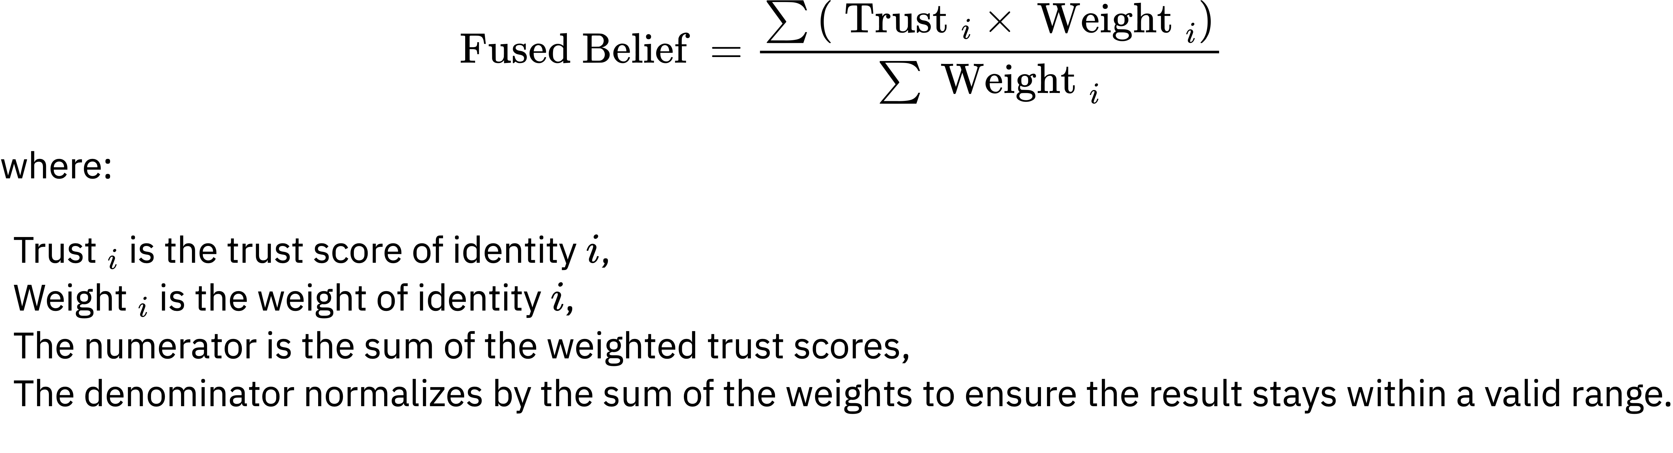

$$P\left(X_{i} = 1\right) = θ, P\left(X_{i} = 0\right) = 1 - θ$$
Equation 2.4: Bernoulli trial for a single trust interaction
$$P\left(S_{n} = k\right) = \left(\frac{n!}{k!(n-k)!}\right) ⋅ θ^{k} ⋅ {(1-θ)}^{(n-k)}$$
Equation 2.5: Binomial probability mass function
$${T̂}_{} = \frac{r}{r + s}$$
Equation 2.6: Naive trust probability estimate

Deterministic versus Probabilistic Approaches
Deterministic trust models assign a static, binary, or categorical value to trust. A node is either "trusted" (1) or "untrusted" (0), or perhaps classified into a fixed set of levels such as Low, Medium and High. This approach is simple and computationally inexpensive, making it prevalent in early access control systems like Access Control Lists (ACLs). It is however structurally rigid and cannot represent uncertainty, incorporate new evidence fluidly, or model the gradual erosion or improvement of trust. It is inherently unsuitable for heterogenous environemts due to trust uncertainty and highly volatile contexts in heterogeneous network enterprise envrionment.
Deterministic models apply fixed rules or algorithms, assigning trust values based on defined thresholds, heuristics, or explicit past behavior. Some key characteristics include Fixed Decision Boundaries, rule-based systems and simplistic static contexts that are easy to interpret. In such scenarios, trust is a binary or discrete value determined by strict conditionsand in some cases if-else conditions, scoring mechanisms, or hard-coded logic is applied for trust calculation. Deterministic models are interpretable and easy to implement but may overfit to static environments. Some approaches to Deterministic Trust Calculation include
- Threshold Models: Trust is assigned if a node meets predefined criteria (e.g., successful interactions >threhold%).
- Weighted Scoring: Nodes accumulate trust points based on actions, and trust is assigned when a threshold is crossed.
- Direct Observation: Trust is computed directly from observed behavior without probabilistic inference.
Deterministic algortihms and models are highly effective in envieonments that require instant trust decisions for new entities based on credentials such as digital certificates, hardware-based attestation, and transparency based on clear, auditable rules such as a Node being trusted based on a valid certificate from an Authority. Furthermore, they are more immune to attacks that manipulate interaction history. Their lack of adaptability, context awareness and reliance on a preexisting PKI or central policy verifying authority leave them severly lacking in heterogenous envrionemnts (Nyangaresi et al., 2022).

Probabilistic Trust Models
Probabilistic models address the limitations of determinism by treating trust as a continuous value, typically a probability, representing the expectation that a node will perform a specific action reliably. This probability is derived from historical evidence of interactions such that Tₓ as the trust value of a node X, ranging from 0.0 representing complete distrust to 1.0 representing complete trust. The core idea is that :Tₓ ≈ E[X] = P(X behaves reliably).
Probabilistic models incorporate dynamicity in trust calculations by factoring in uncertainty likelihoods based on changing conditions in networks. This allows for consideration of parameters that have probabilities of existenc and change, making them suitable for highly variable heterogeneous environments. Some of the key characteristics include evaluation of trust as a Random Variable, continuous evalutation and tolerance to errors and change. Trust values are represented as probabilities based on previous transanctions, and interactions, behaviors, and indirect recommendations in cases where there is trust transmission. Trust is also recalculated dynamically as new evidence and interactions arrive thus relying on feedback loops for improvements in subsequent interactions. feedback) arrives. These feedback loop and subsequent improvements make probabilistic models better at handling noise, partial data, and inconsistencies in the network or network metadata.
Some approaches for dyamicity in to probabilitstic trusts calculation include Bayesian Networks which achieve dynamicity through iterative updates of trust scores using Bayes' theorem based on prior knowledge and new observations as illustrated in on equation 4.1. Other approaches include Markov and Hidden Markov Chains and models where trust values are incremented or decremennted based on transitions between states over time, with probabilities dictating the likelihood of moving from one trust level to another. Latent trust levels that are not directly observable but inferred through interaction patterns. Finally, Gaussian and Continuous Distributions where Continuous trust values (x∈(0,1)) can be modeled using distributions like the Continuous Bernoulli for probabilistic fusion of trust from various sources. The results include integral values that can be collapsed into blacklists and/or whitelists based on the access threhold values.

$$P(\text{ Trust }∣\text{ Evidence })=\frac{P(\text{ Evidence }∣\text{ Trust })⋅P(\text{ Trust })}{P(\text{ Evidence })}$$

Hybrid Models (Probabilistic + Deterministic)
The escalating complexity and adversarial sophistication inherent in heterogenous networks have exposed the limitations of monolithic trust management architectures. Pure probabilistic models such as Bayesian and EigenTrust excel at leveraging historical interaction data to infer future behavior but often lack context-awareness and can be slow to react to novel attacks. Conversely, pure deterministic models such as rule-based systems and policy-driven access control provide immediate, verifiable decisions based on predefined criteria (e.g., certificates, device types) but are inherently rigid and cannot adapt to evolving node behavior or subtle malfunctions.
The integration of these paradigms into Hybrid Trust Models represents a significant evolutionary step. This fusion creates systems where the adaptive, learning capabilities of probabilistic methods are guided and enhanced by the structured, verifiable logic of deterministic frameworks. The core thesis is that such a hybrid approach mitigates the weaknesses of each constituent model, yielding a trust management system that is simultaneously adaptive, robust, explainable, and context-aware.
Combining probabilistic and deterministic approaches leverages the strengths of both methods; For instance a node with 95% data accuracy is assigned deterministic trust. Over time, Bayesian updating refines the trust score based on ongoing performance. The Initial Trust Assignment cab be based on deterministic rules for initial trust assessment suxh as pass/fail based on basic performance while the Dynamic Trust Updates can be based on probabilistic methods to update trust levels continuously as new interaction data becomes available. In heterogeneous networks, the choice between probabilistic and deterministic trust calculations depends on the network's variability, scalability needs, and tolerance for uncertainty.
An effective hybrid model is not a simple average of two scores. It is a structured integration where each paradigm operates on, and informs, the other. Two variations of hybrid architecture may be utilized for trust estimation and calculation in heterogenous enterptise environments
- Deterministic core with Probabilistic updates: This is a common and logical structure designed as a bootstrapping architecture to solve the cold-start problem where the initial trust value is difficult to determine for a new device. Its initial phase is deterministic such that a new joins the network and the initial trust is not set to a default middle value but is derived deterministically from its credentials such as a manufacturer-issued certificate, a hardware-rooted identity or a device type/role). This provides a secure and justified starting point for trust calculation. The second phase is based on Probabilistic Refinement; once the node begins interacting, a probabilistic engine such as a Bayesian updater or tempral trust decaytakes over and continuously monitors the node's acttivities such as packet forwarding, and data validity, and dynamically adjusts the initial trust score upwards or downwards. (Nyangaresi et al., 2022).
- Probabilistic Core with Deterministic Guardrails (Constraint-Based Architecture):This model’s primary trust value is generated probabilistically, but deterministic rules act as overriding constraints or context modifiers. This is based in a costraint based architetcure such that the deterministic models provide threshold based guardrails. For example, a Bayesian network or a fuzzy logic system computes a continuous trust value based on interaction history for a device or user and a policy engine applies deterministic rules that can cap, floor, or invalidate the probabilistic score based on context and dynamicity supported within a heterogenous network. Critical and non-negotiable vlue such as certificate validity, lack of MFA or untrusted devices automatically invalidates the trust level regardless of the threhold (Alshehri & Hussain, 2021).
- Hierarchical Fusion Architecture: this architecture focuses on trust as modular concept that can be evaluated in different paradigms. Trust is broken down into multiple dimensions, each calculated using the most appropriate method, and then fused into a final composite score. For example, Identity Trust for user credentials can be calculated deterministically while their behavioral trust (trust of appliations, devices or networks) is calculated probabilistically based on transaction history. Ultimately, the contextual trust could involve both deterministic rules probabilistically such as device type influencing a probabilistic device complience score within the network (Wang et al., 2023).. As such as weighted fusion function, would potentially learned adaptively by dynamically combining these dimension scores as shown in EQUATION X:
T_final = w1 * T_identity + w2 * T_behavior + w3 * T_context.

$$T_\text{final }=w1*T_\text{identity }+w2*T_\text{behavior }+w3*T_\text{context }.$$

Hybrid approaches are more complex and challenging to implement due to factors such as finding an optimal Fusion Strategy. Determining the weights for combining scores is highly dependent on diffenet organizational network structures. Machine learning models can be used to dynamically optimize these fusion parameters based on network outcomes (Liang et al., 2022). Increased Complexity and explainability are also active hinderances to hybrid models. Ensuring efficiency and low overhead on resource-constrained devices is a challenge. While the deterministic parts are explainable, the fused result is a gray box making the entire decision-making process less transparent, especially for audit of trust decisions. Finally,a lack of standardized metrics and interfaces for exchanging trust information between different hybrid systems hinders interoperability across heterogeneous network domains.

Therefore, Hybrid probabilistic-deterministic trust models represent a sophisticated and necessary advancement for securing complex, modern networks. By synergistically combining the adaptive intelligence of probability with the rigid security of determinism, these models overcome the fundamental limitations of their pure-form counterparts. They provide a robust solution to critical problems like cold-start, enhance resilience against collusion attacks, and integrate crucial context into the trust calculus. This work thus looks at a fused hubrid and subjective logic approach to contextually and dynamiacally weight trust nbase don device, network, user and application trust tenets of ZTA as the cornerstone of next-generation dynamic trust calculation in heterogenous systems.

Dynamic Trust as Binomial and Bernoulli Events
At its core, the concept of trust in a networked interaction is fundamentally a prediction of future behavior based on past evidence. This aligns perfectly with the principles of probability theory. Modeling direct, binary interactions (success/failure, honest/dishonest) as a sequence of Bernoulli trials and aggregating their outcomes into a Binomial distribution provides a mathematically rigorous, lightweight, and intuitively explainable foundation for dynamic trust computation. This approach is particularly powerful in large-scale, resource-constrained environments like the Internet of Things (IoT) and sensor networks, where simplicity, low computational overhead, and scalability are paramount.
We now have a mathematical language for describing trust. But why don't current security architectures use it? Part II investigates the limitations of existing Zero Trust frameworks.

